Graded Problems for Module 4
The graded problems in module 4 involve SELECT statements for single table problems with conditions, joins with two tables, and row summaries involving single tables. You should execute the statements using either Oracle or MySQL.
- List the city, state, and zip codes in the customer table. Your result should not have duplicates.
QUERY: SELECT DISTINCT CITY,STATE,ZIP FROM CUSTOMER;
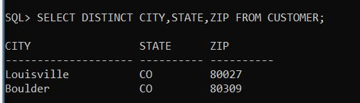
- List the name, department, phone number, and email address of employees with a phone number beginning with “3-”.
QUERY:
SELECT EMPNAME,DEPARTMENT,PHONE,EMAIL FROM EMPLOYEE WHERE PHONE LIKE '3-%';
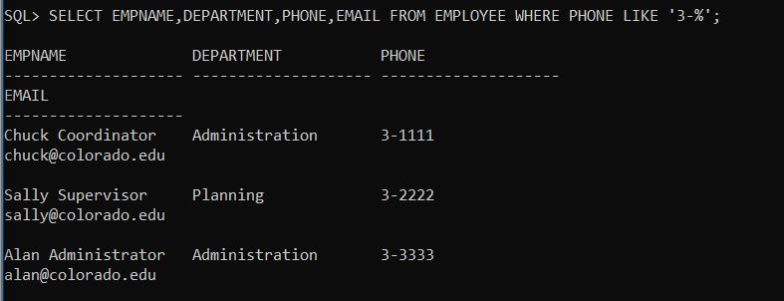

- List all columns of the resource table with a rate between $10 and $20. Sort the result by rate.
QUERY: SELECT * FROM RESOURCETBL WHERE RATE BETWEEN 10 AND 20 ORDER BY RATE;
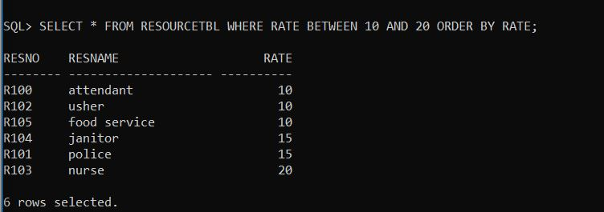

4. List the event requests with a status of “Approved” or “Denied” and an authorized date in July 2018. Include the event number, authorization date, and status in the output
QUERY: SELECT EVENTNO,DATEAUTH,STATUS FROM EVENTREQUEST WHERE (STATUS='APPROVED' OR STATUS='PENDING') AND (DATEAUTH BETWEEN '01-JUL-2018' AND '31-JUL-2018');
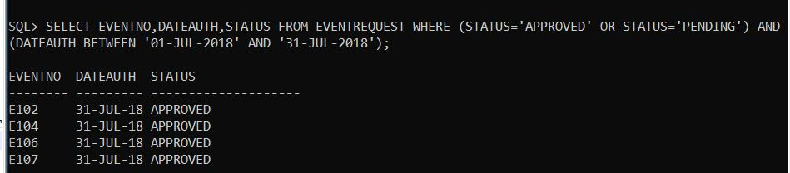

- List the location number and name of locations that are part of the “Basketball arena”. Your WHERE clause should not have a condition involving the facility number compared to a constant (“F101”). Instead, you should use a condition on the FacName column for the value of “Basketball arena”.
QUERY: SELECT LOCNO,LOCNAME FROM LOCATION JOIN FACILITY ON LOCATION.FACNO=FACILITY.FACNO WHERE FACNAME='Basketball arena';
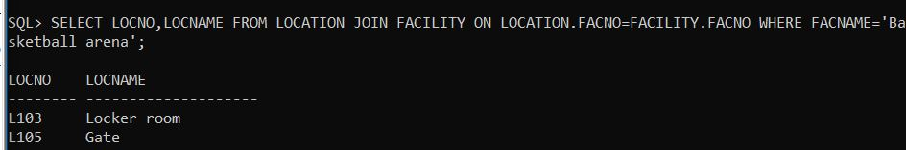

- For each event plan, list the plan number, count of the event plan lines, and sum of the number of resources assigned. For example, plan number “P100” has 4 lines and 7 resources assigned. You only need to consider event plans that have at least one line.
QUERY: SELECT PLANNO,COUNT(LINENO) AS COUNT_OF_LINES,SUM(NUMBERFLD) AS SUM_OF_RESOURCES FROM EVENTPLANLINE WHERE LINENO>=1 GROUP BY PLANNO;
